Creating a Product
ATTENTION! If you are copying content from Word, PDF’s, a website or anywhere else, PASTE IT INTO NOTEPAD FIRST, then copy it from there and post it into the WYSIWYG editor.
Failure to do so can cause problems with the style and formatting of the content.
- From the administration menu choose 'Create Content'
(Hovering)

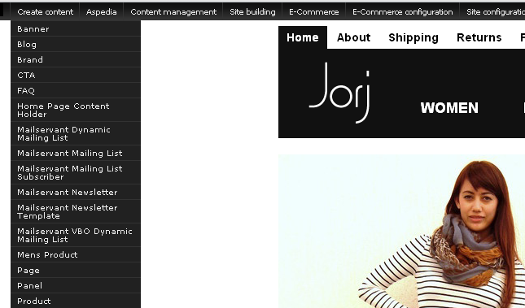

Note: You can either hover over the ‘Create Content’ tab and select product, or you can click ‘Create Content’ then choose product when the next page loads.
(Not hovering – Just clicking ‘Create Content’)
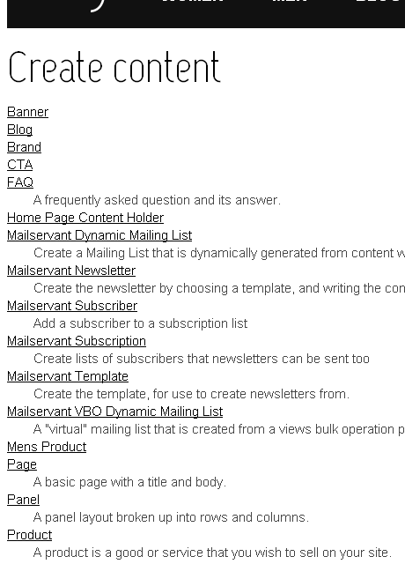
- Select ‘Product’ from either menu displayed, whether you hover over the admin bar or click ‘Create Content’ tab.
- You will come to a page which will give the option to choose the following:
- Product Variations allows a product to have multiple available versions with some variation and optionally unique prices per variation. (ie Size, Colour, finish)
- A shippable product is a tangible, physical item. Optional features includes inventory control and availability estimates but no variation in sizes and colours
- A Gift Certificate Creates Certificates for customers to use for later purchases.
- A Non Shippable product is more flexible and can represent a good or a service. (ie downloadable product, or 'book and pay' for a service).
Note: Certain websites may only have certain options available due to the type of products they offer.
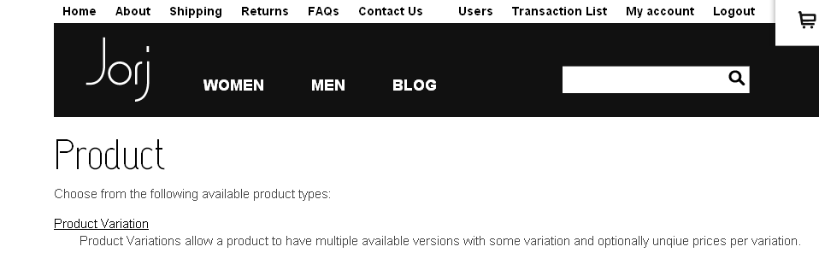
- Select the type of product you wish to create.

- Once selected, a page will load with a WYSIWYG editor and some other fields for you to add information into. Fill these out.
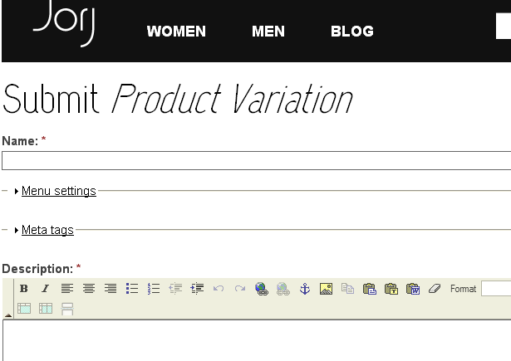
Note: Areas that have a red asterisk next to it NEED to be filled out otherwise the product will not be created.

A few things to remember:
- If you want your item to appear in more than one category (ie in tops as well as specials), hold down the Ctrl Key on your keyboard while you select each category with your mouse.
- Complete all the required fields including 'Sell Price'. This price should include the GST, however it's dependent on the site itself and how it's themed based on what you've ask in your set up
- Leave the 'Add to cart' link as the default unless you are setting up a Variation Product, then you should choose 'Hidden'.
- If you want to manage how many items you have with inventory control - then tick the 'Manage Stock' box
- The Product Weight and Size fields are mainly for your reference and are not required for you to complete. If you are using a complex shipping method that requires weight and size, there will be other fields you will have to complete with that module. You will be given separate instructions for these fields.
- If you are not sure about the fields and whether you require them, such as 'renewable schedule' and 'priority' - leave them as the default. We will give you instructions if you need to choose these.
Adding an image to the product:
Depending on your set up and what product option you chose, there should be an ‘Image’ field.
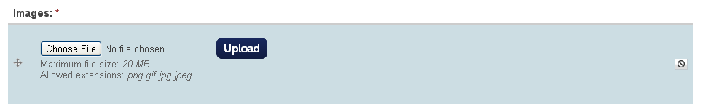
- Select the ‘Choose File’ button. A pop up box will appear.
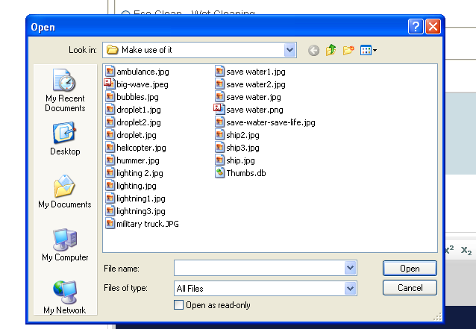
- Select the image you wish to upload.
Note: Only images with the file extensions .png, .gif, .jpg or .jpeg are allowed
(Tip: If you have an image that has the wrong extension, open it in the program ‘Paint’, click ‘Save as’ and change the file extension underneath the file name to one of the accepted extensions.)
- Once you’ve selected the image to upload, select ‘Open’. You should now see the image name next to the ‘Choose File’ button.
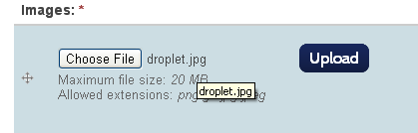

- Select the ‘Upload’ button to preview the picture and add alternative text.
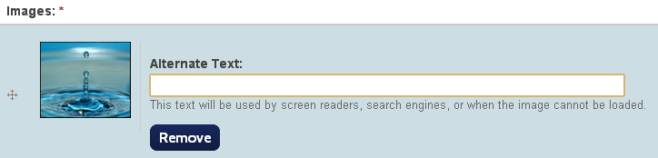
What is Alternative Text?
This helps Google to decide when to show this image.
An example for the image above:
It’s a picture of water so we could make the alternative text ’Water’, any user who searched ‘Water’ in images will stumble upon this picture.
From this area, you can also remove the image if you do not want it there.
ATTENTION: For products, images are essential. If you do not select one, you will not be able to create the product.
Once you have filled out all required fields and selected an image to be uploaded, continue down to the bottom of the page where you see ‘Save’ and ‘Preview’ buttons. You can preview what it will look like before saving the page or you can just save straight away.
Congratulations, you have now created a product on your site ☺

